Unit 2 Assignment

Desmond Hughes

Purdue University Global

HU200: Arts and Humanities

Elliot Crozat

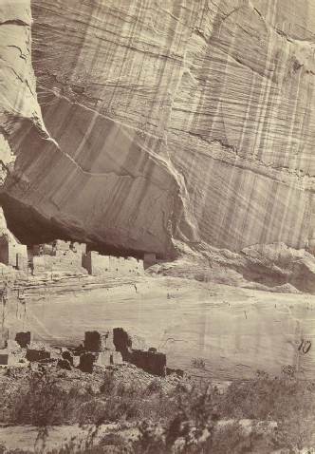

On the left is a photo from a photographer named Timothy O’Sullivan, and it is titled Canyon de Chelly, Arizona. On the right is my picture I took from the top of the largest Ferris Wheel in Las Vegas, Nevada. The photo by Timothy O’Sullivan shows a location that starts at the bottom of a canyon, then there are small buildings under its shadow, with a black and white color filter with a light color contrast. My photo on the right show’s buildings surrounded by mountains, with a nice blue sky that fades away into the mountains. I learned that Timothy O’Sullivan adds a smooth texture to the canyon. I was also kind of confused and had trouble from the photo determining if the buildings were buildings or rocks until I read the text. O’Sullivan also waited for the right moment to take the picture making sure that the light hit the side of the canyon right. It shows me the time and the patience the artist put into the art, and how he adds detail to the texture and contrast. Compared to mine all I did was take a picture thinking this is a great view, on a nice sunny day. I put these two photos together because they both are photos of landscapes and both give a sense of the desert more the Canyon de Chelly, Arizona than mine. Canyon de Chelly, Arizona by O’Sullivan shows that if I add more texture, it shows how much more I can get out of the photo especially with the right lighting. These photos stood out to me by looking at the photo in the textbook I automatically thought of my photo in the Ferris Wheel. Both of these pictures could be influenced by the culture from the love of nature, whether if it’s O’Sullivan and the bottom of a canyon or me and mountains surrounding a city.

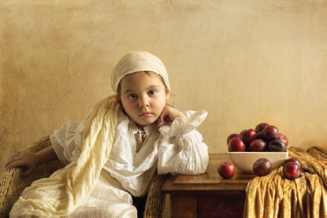

The photo on the left is named Plums by Bill Gekas. The photo was inspired by an old painting. Plums shows a little girl wearing all white, in a pose with her elbow on the table, with a plain expression on her face, and her hand on her cheek, while her other hand is place on the arm of the chair she is sitting in, with a tan color background. She is sitting next to a table with a bowl of plums next to a blanket, with three plums out of the bowl. The photo on the left is a toddler with his arms crossed, with a smile on his face. He is wearing a yellow shirt with a black vest, with a black mixed with a dark yellow background. Bill Gekas was photographing his daughter, and put her in different poses, capturing the seventh century, which I can see now since the text mentioned it. “At times, he needs cranes, lights, and as many as thirty assistants to get the effect he wants. He spends months on a single image.” (Jacobus, 2022). It shows how much passion he has in his work and try to make the picture perfect in his eyes. I picked to analyze the two photos together because they both are photos of little kids. When I was scrolling and looking for pictures in the textbook I noticed Bill Gekas photo, which made me think of my photo as a little kid. The pictures indicate that children can be the main focus on a photo whether if it’s art or not. The photo by Gekas stood out to me by being a nice calm photo. These photos were influenced by trying to resemble older times in the past in how they dress.

Reference

Jacobus, L. (2022). Humanities through the Arts (11th ed.). McGraw-Hill Higher Education (US). <https://purdueuniversityglobal.vitalsource.com/books/9781264360215>

Canyon de Chelly, Arizona by Timothy O’Sullivan

Plums by Bill Gekas